***Enhanced Job and Candidate Application***

***User Manual***

computech logo



Version: 1.1

04/21/2015

**Prepared by:**

Simul Kadakia

Wesley Trescott

Gagandeep Singh

## Navigating the Home Page

Begin by accessing the Home page of the web application. You may be accessing the site from a mobile device, but if you are using a desktop environment, the screen should look like this:

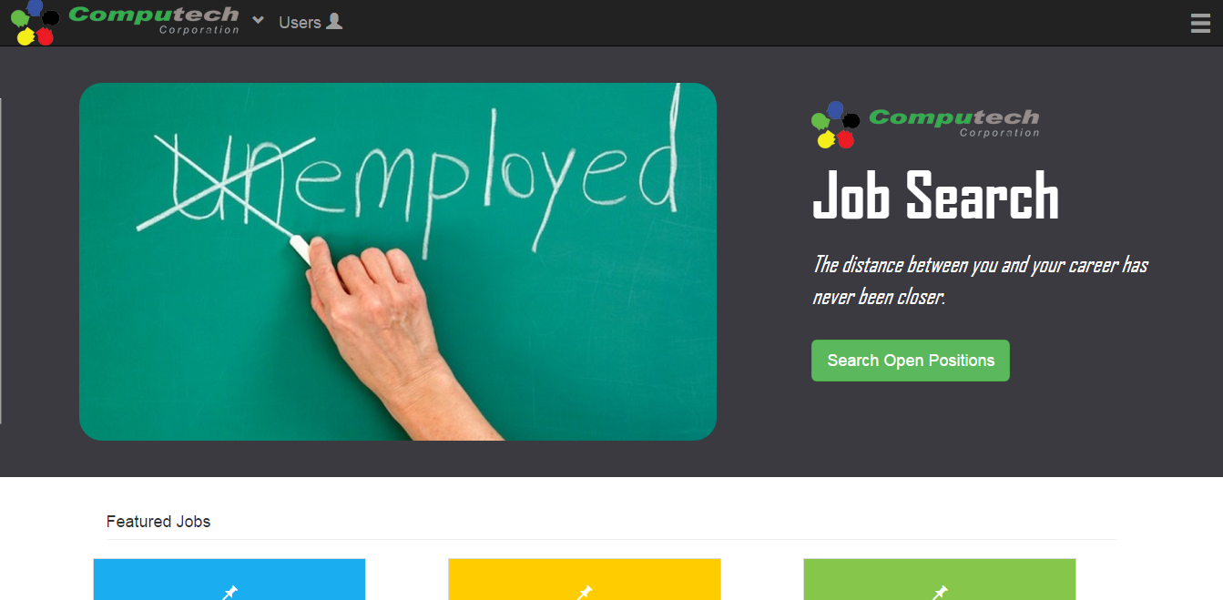

The top of the Home page consists of a welcome message and a button link to the job search page. You will also notice the following footer on each page of the website:

Clicking the “Home” link from anywhere in the site will navigate you to this home page; or, if you are a registered user and signed in to the application, clicking this link will take you to the User Dashboard page. For more details on this page, see section 8, “Navigating the User Dashboard.” Clicking on the “About Us” link will take you to the “About Us” page of the main Computech site, which gives more details about Computech, its history, products, and services. Clicking on the “Contact Us” link will take you to the Contact page of the web application; for more details, see section 4, “Contacting Computech.”

Below the Home page welcome message is a listing of six featured jobs that may be of interest to you.

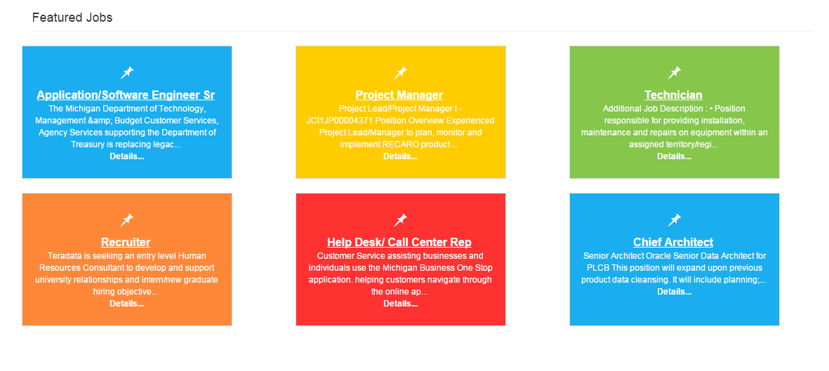You will notice that each featured job contains a “Details” link. Clicking this link will navigate you to the Job Details page discussed next.

## Job Details Page

The job details page looks as follows: 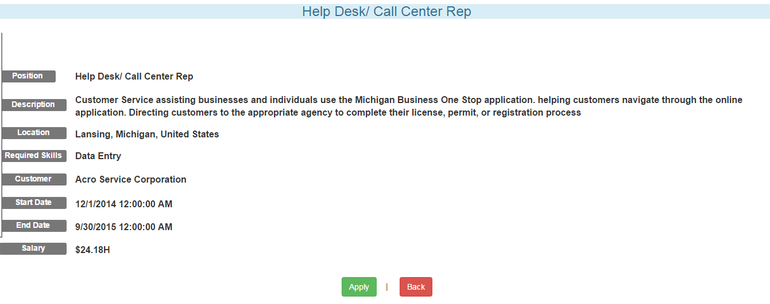

A page contains detailed information regarding the position title, job description, location, required skills, customer offering the job, job start and end dates, and job pay rate. There are also buttons giving the choice to apply for the job or go back to the Home screen. If you are not logged in to the web application, clicking the Apply button will navigate you to the Login page, as users must be logged in to apply for jobs. For now, we click the Back button to navigate us back to the Home screen.

Now that we are back on the Home screen, we click on the “Search Open Positions” button.

This navigates us to the Job Search page.

## Job Search Page

The Job Search page looks as follows:

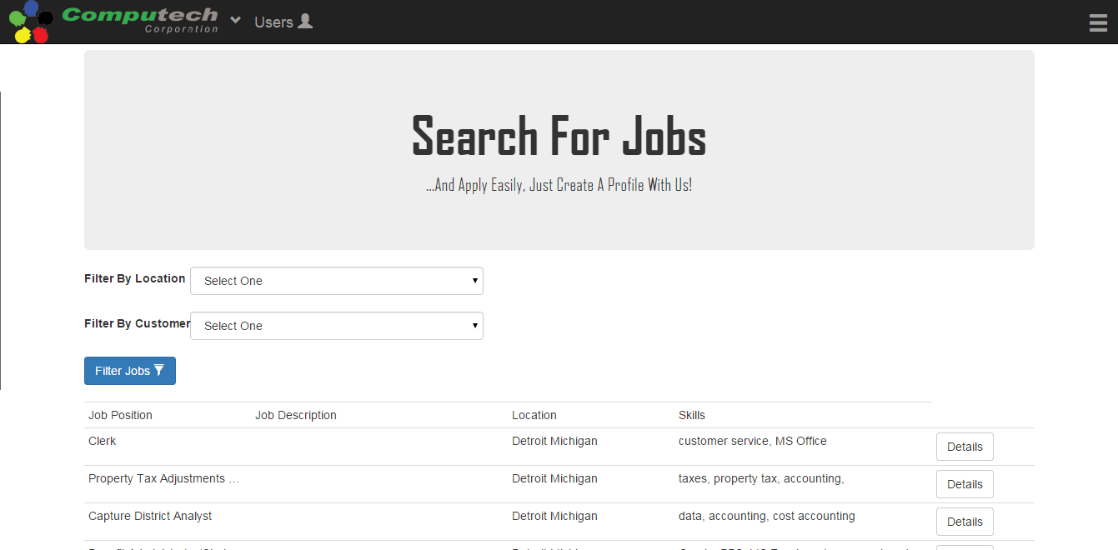

You will notice a large table taking up most of the page. This table contains a listing of all jobs available at Computech, including the position tile, description, location, and required skills for the job. There is also a “Details” button at the end of each entry in the table. Clicking this button will navigate you to the Job Details page discussed in section 2.

You will notice two drop down menus located near the top of the page, which allow the user to filter the jobs based on job location and customer. The user selects criteria from either one or both of the dropdowns and clicks on the “Filter Jobs” button. This displays the jobs matching the search criteria. For example, when searching for jobs in Alpharetta, Georgia, the user obtains the following results:

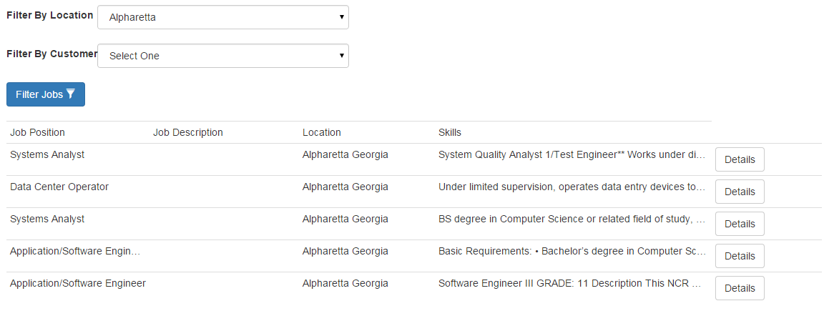

## Contacting Computech

If the user needs to contact Computech with any questions or concerns, this can be done by using the “Contact Us” page. From any page in the web application, click the down arrow in the top navigation bar next to the Computech logo, and select the “Contact Us” link:

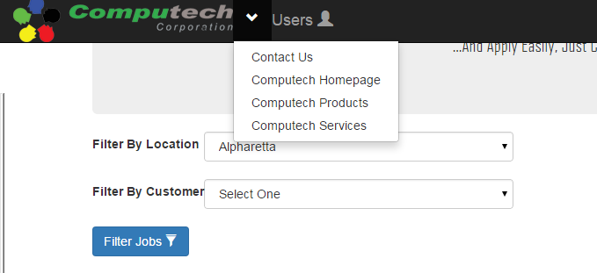

This navigates the user to the following screen: 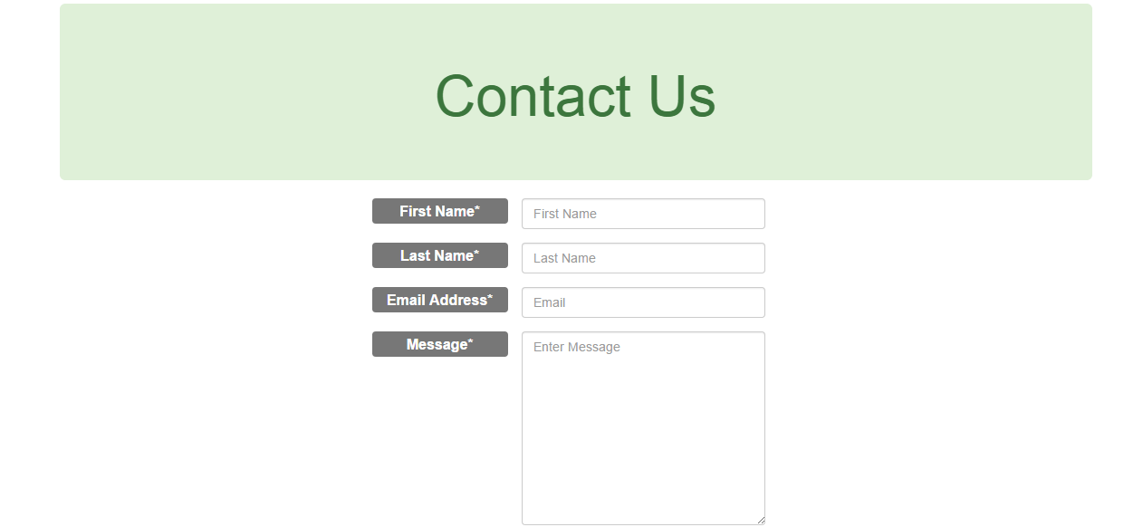

To contact Computech with your message, it is necessary to fill in each field of the form. If all fields are not completed, an error message will be displayed. When all fields are filled in, click the “Submit” button at the bottom, and Computech will receive your contact information and message, and follow up with you as necessary.

## Registering Users

To apply for jobs, you must create a user account. From any page in the web application, click on the “Users” icon in the top navigation bar, and from the dropdown menu, click on “Register”:

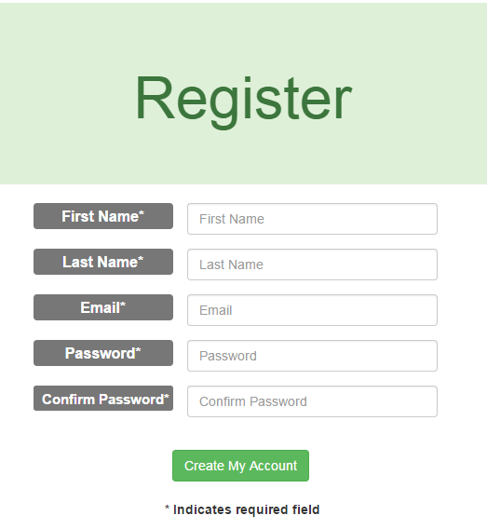This navigates you to the Registration page. Fill in each field of the form and click “Create My Account.”

The system will then send a validation email to the email address you provided in the form. Navigate to your email inbox, open the email you received from Computech Corporation, and click on the link provided in the email. This will return you to the Computech web application Login page.

## Logging In

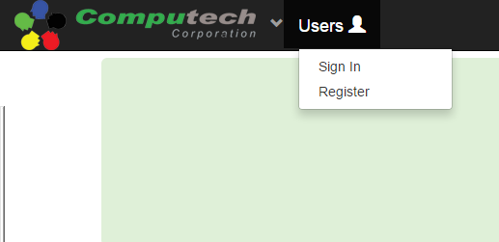The user can access the Login page by clicking on the “Users” icon on the top navigation bar and clicking on “Sign In” from the dropdown menu:

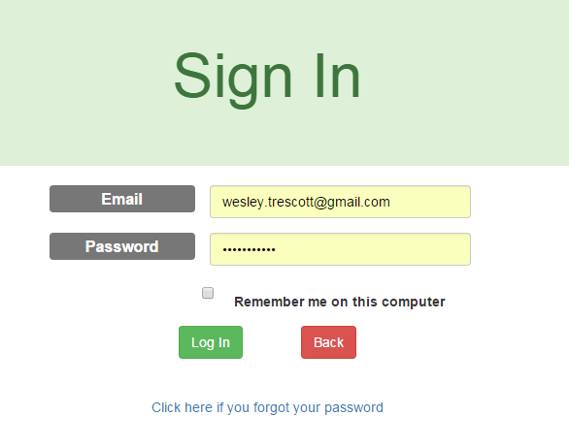This takes you to the Login page:

After filling in the required credentials and clicking “Log In,” the user will be authenticated and navigated to the secure User Dashboard portal. For details on the User Dashboard page, see section 8, “Navigating the User Dashboard.” Clicking on the “Back” button returns the user to the Register page. Also, if you forget your password at any time, it can be retrieved as discussed in section 7 below.

## Retrieving Forgotten Passwords

If you ever loose or forget your password, you can reset it. To request a password change, navigate to the Password Retrieval page. You can access it by either clicking on the hamburger button in the top navigation bar and then clicking on “Forgot Password” from the dropdown, or by navigating to the Login Page and then clicking on “Click here if you forgot your password.”

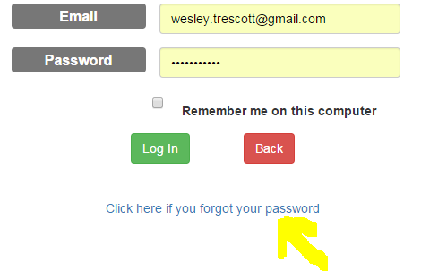 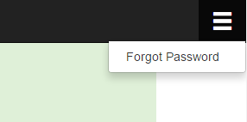

This navigates you to the following screen:

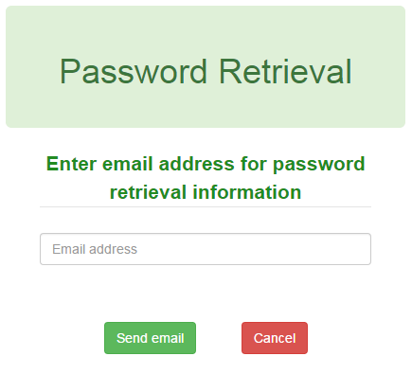

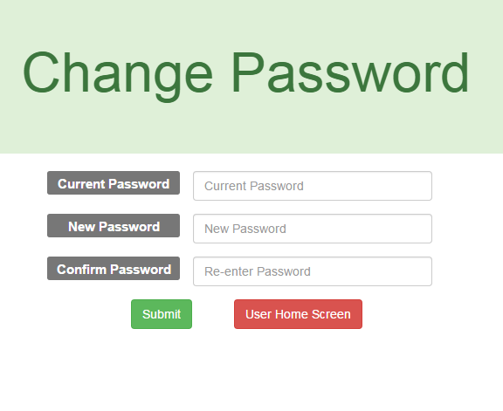Entering your email address and clicking on “Send Email” will send an email to your inbox if the email provided is associated with a user account in the system. Navigate to your email inbox and open the email from Computech Corporation. Click on the link provided, and you will be navigated back to the Computech web application to the Change Password screen:

Entering in the credentials and clicking submit will reset your password so you may now access your user account.

## Navigating the User Dashboard

If you are a registered user, you can log into your user account and apply for jobs. To log in, follow the instructions in section 6 above. Once you are signed in, you will see the following screen:

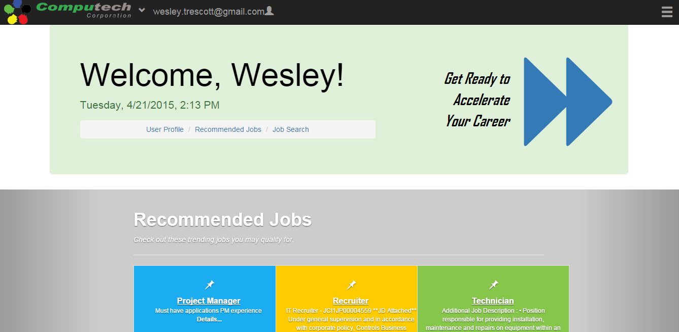

Previously, clicking on the Computech logo in the top navigation bar directs you to the Home screen; but now that you are signed in, clicking on the logo takes you to the User Dashboard screen. The top header displays your name and navigation information for the page. There are two main sections, the Recommended Jobs section and the Job Search section.

The Recommended Jobs section of the User Dashboard looks as follows:

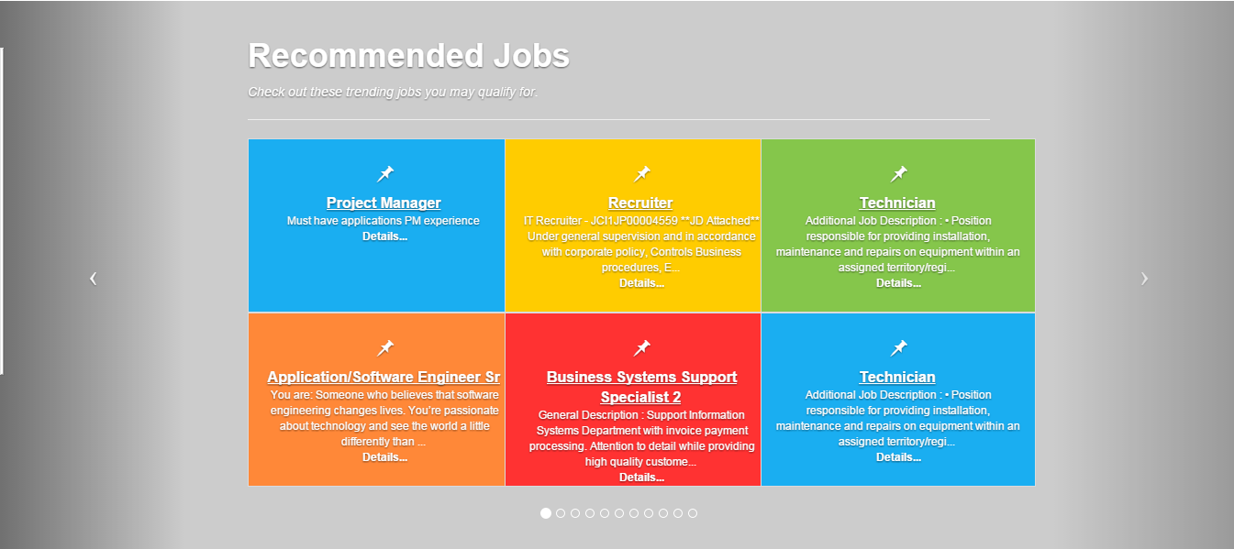

The display is a scrolling pane that lists, in pages of six each, jobs that potentially fit your skill set. As with the application Home page, clicking on the “Details” button navigates you to the job details page, allowing you to view information job details and apply for the job. To view different pages of recommended jobs, simply click the left and right arrows on the screen or use the bottom navigation control to scroll.

Below the Recommended Jobs section is the job search section, which looks as follows: 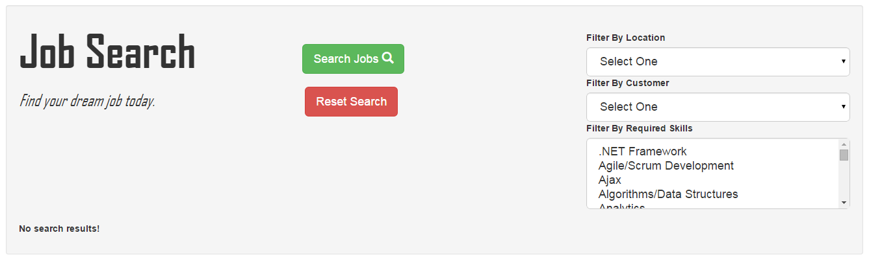

This section functions similarly to the Job Search page discussed above. Simply select required location, customer, and required skills credentials (as many skills as wished may be selected) and execute the search by clicking on “Search Jobs.” The result of the search will be displayed in a table identical to that shown in the Job Search page in section 3 above. You can apply for jobs you are interested in by clicking the “Details” button in the search results and clicking on the “Apply” button in the details page.

## Updating User Profile

When you are logged in, you may update your profile information at any time. This information is sent when you apply for a job, and your skills information is used to match you with recommended jobs. To update your profile information, click on the hamburger button in the top navigation bar and click on “Update Profile” in the dropdown menu:

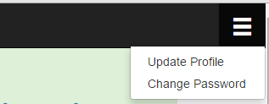

This will navigate you to Profile page, where you can update your information. Fields will be prepopulated with data already saved, and you can update or delete this information to your liking.

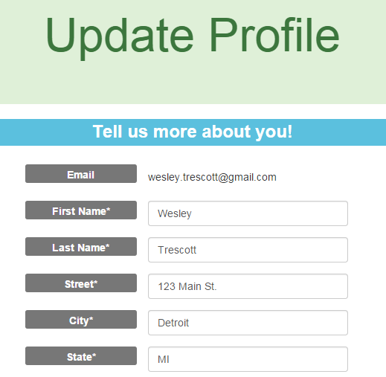

You also have the opportunity to upload a resume to your profile that you can submit when you apply for a job. To access the resume upload page, click on the link “Click here to upload your resume” at the bottom of the form. This takes you to the following page:

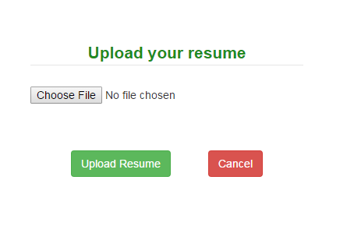

Here, you may choose a resume in .doc, .pdf, or .txt format from the file dialog and upload it to your account. Clicking “Cancel” returns you to the Profile page. In the Profile page, buttons at the bottom of the page give you the option to save the changes to your profile information, or return to the user dashboard.

## Applying For a Job

Once your profile is up-to-date and you have found a job for which you wish to apply, click on the “Apply” button from the Job Details page. This will take you to the Job Application screen as follows:

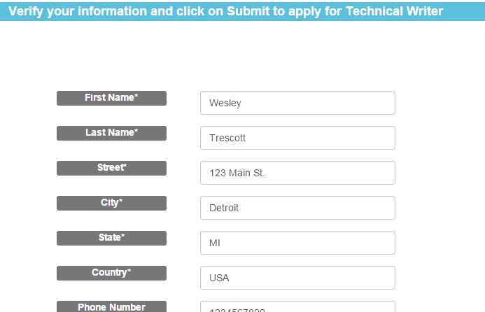

Your profile information is automatically populated in the application fields, but you can edit the values if you wish to make changes for this particular application. You also have the option to attach a resume from your profile to the application. Clicking the “Submit” button will submit the application and clicking “Cancel” will return you to the Job Search page.

## Logging Out

Once you are finished applying for jobs, you can exit the user portal. You will notice that the “Users” icon is replaced by your email address in the top navigation bar when you are logged in. To sign out, simply click on this button, and click on “Sign Out” from the dropdown menu.



You will now be redirected to the Computech Home page. Thank you for using the Computech Job Search web application!